Test
Write the instruction for each step in the space beneath its picture.
Step 1
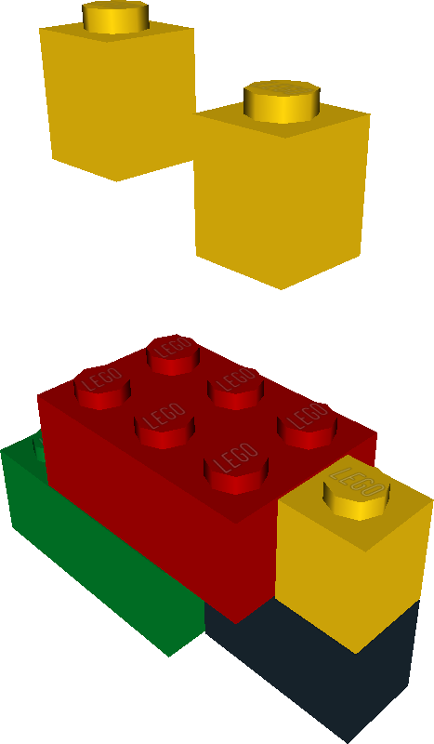

Step 2


